# Exercises: How to Mine Storj

This document describes the exercise assignments for the ["Blockchain Academy" course @ Software University](https://softuni.bg/courses/programming-fundamentals). In this lesson, we learned about Notable Blockchain Projects. As mentioned one of them is Storj. In this exercise, we shall download and install Storj wallet, create payment address and then download and install Storj. After that, we will setup Storj and start mining.

It is time to learn how to mine Storj!

## Create a Storj Wallet

The first thing we will need is a place to store our newly mined Storj coins. Since Storj is an ERC-20 Token, we can use <https://www.myetherwallet.com/>. We are going to create a wallet with MEW. This wallet allows you to store Ethereum and ERC-20 tokens and of course Storj.

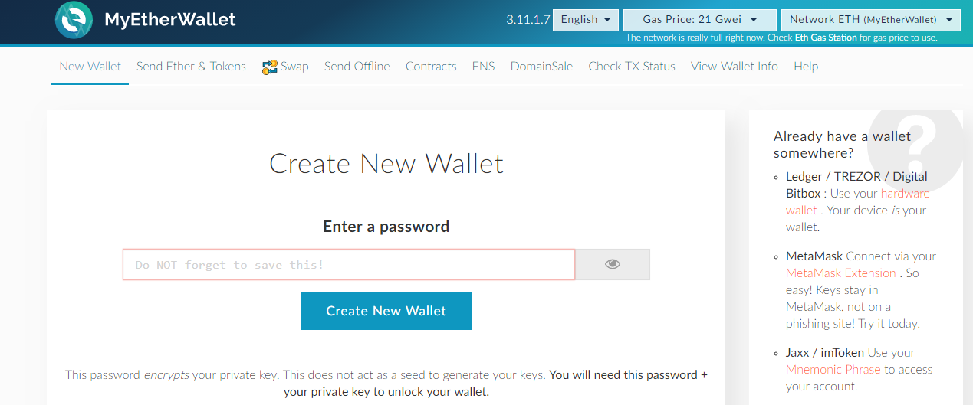

Log in with **MetaMask**:

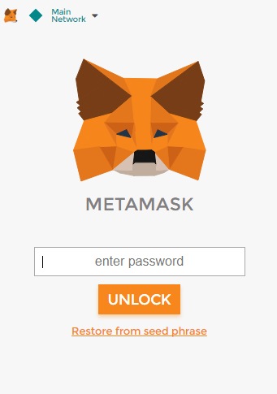

Go to [**View Wallet Info**]and connect with **MetaMask**

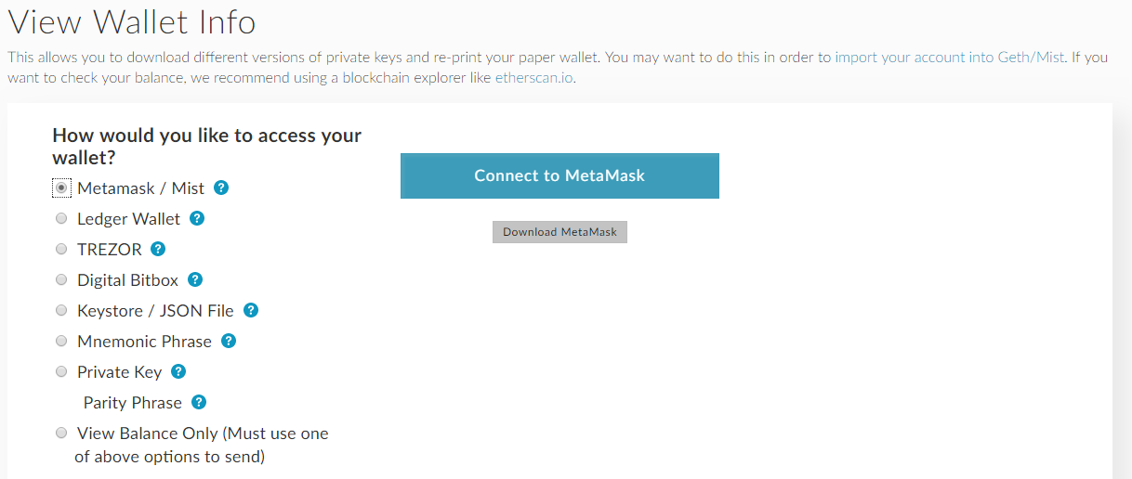

You can use your **Ethereum Address** for storing your Storj

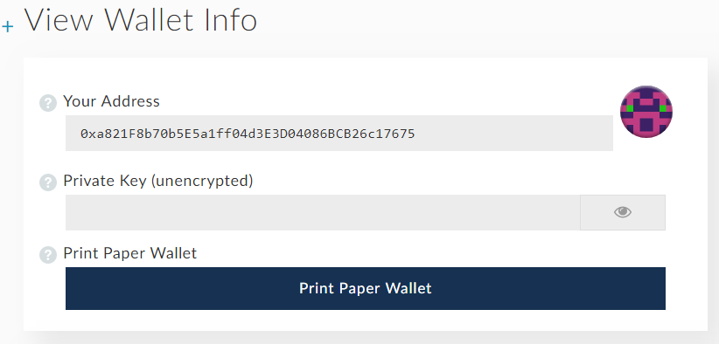

When you want to check your balance, you go to Token Balances and find **Storj**

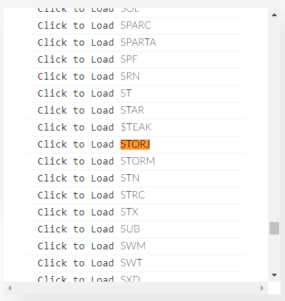

## Download and Install Storj

1. Go to <https://github.com/Storj/storjshare-gui/releases/> and download the latest version

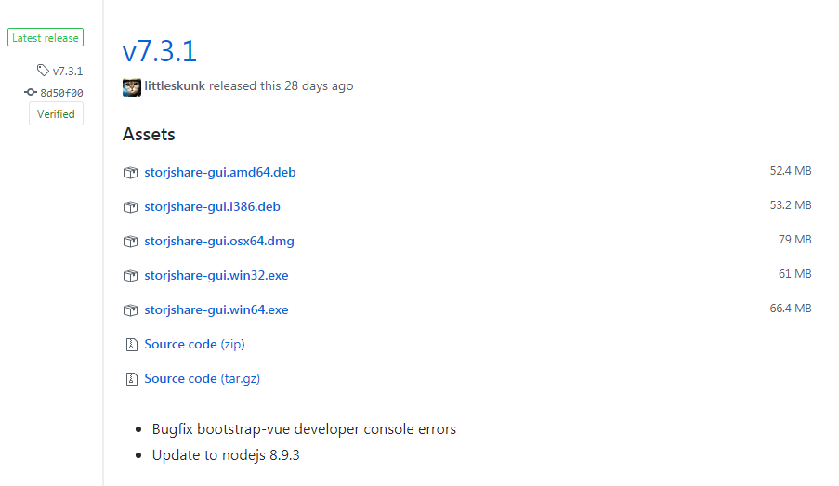

1. Double-click the downloaded Setup and install Storj

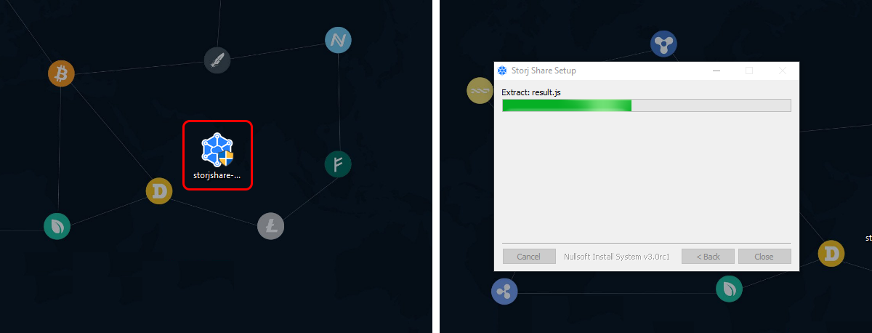

1. When the installation is complete, agree to the terms & conditions

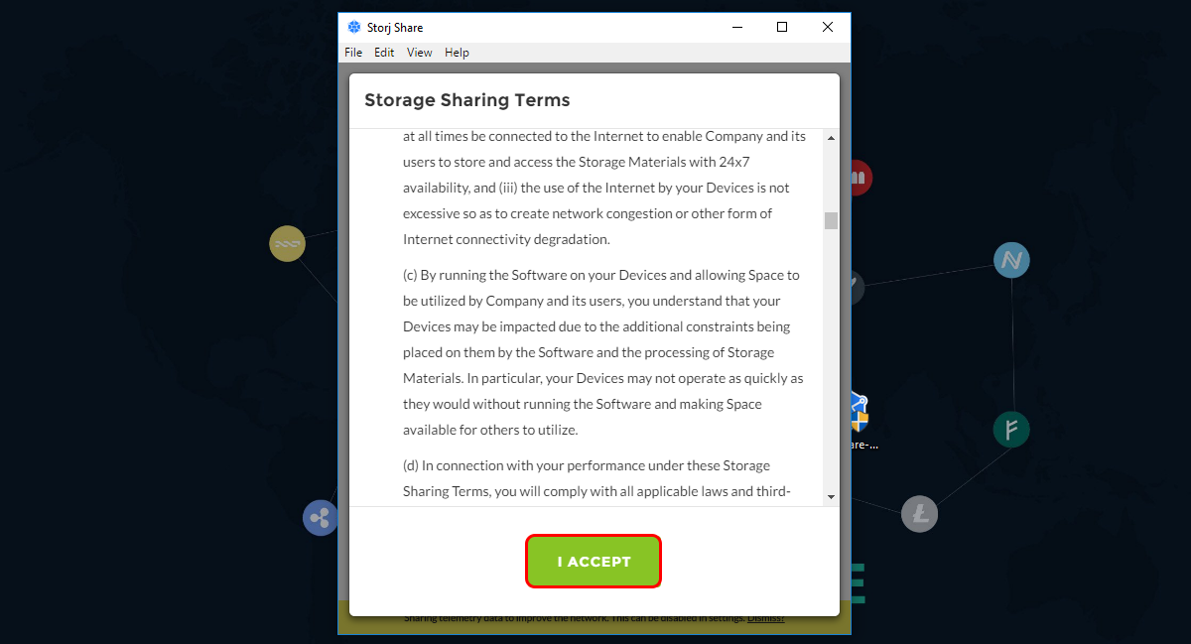

## Mine Storj

Now that you have installed Storj and agreed to its terms and conditions, Storj will be automatically open. This is your main interface and it will allow you to set up where Storj will keep the encrypted files, which wallet to mine to and so on. Let’s get started:

## This is the welcome screen. Click [Start Setup]

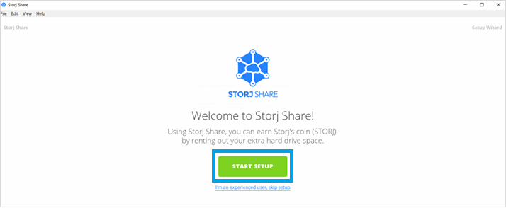

## Copy the wallet address from MEW and insert it in the field as shown in the screenshot. Click [Next]

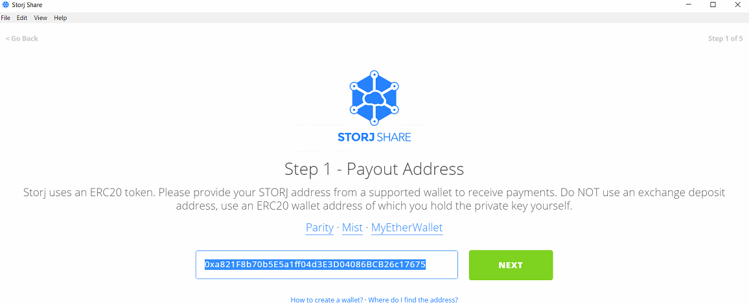

## In order to start mining, you will need to choose a place to store the uploaded files. Click [Choose Files]

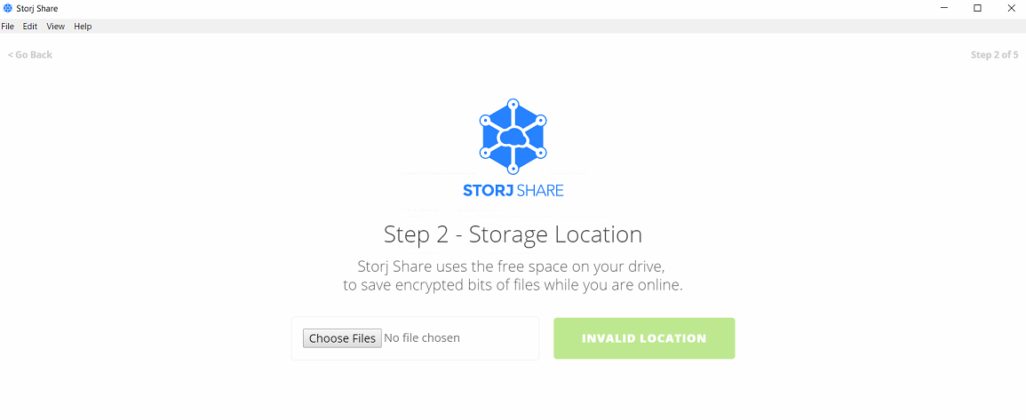

## Select the drive where you want to store your files and create a new folder, then click [Select folder]

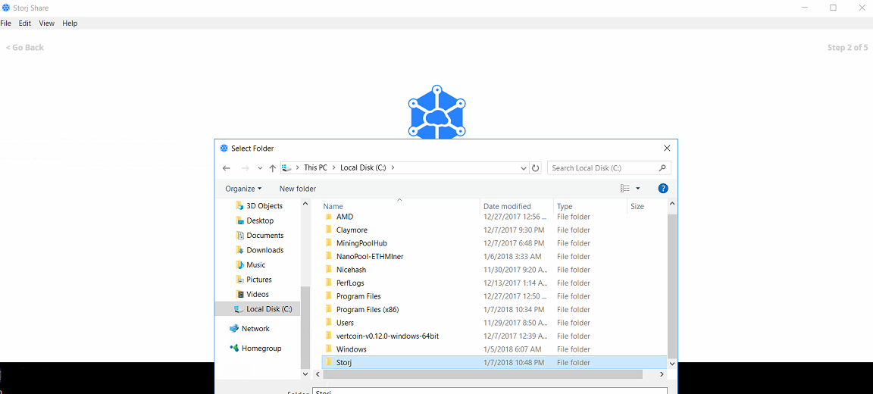

## Define the storage space you are willing to make available. More space == more Storj

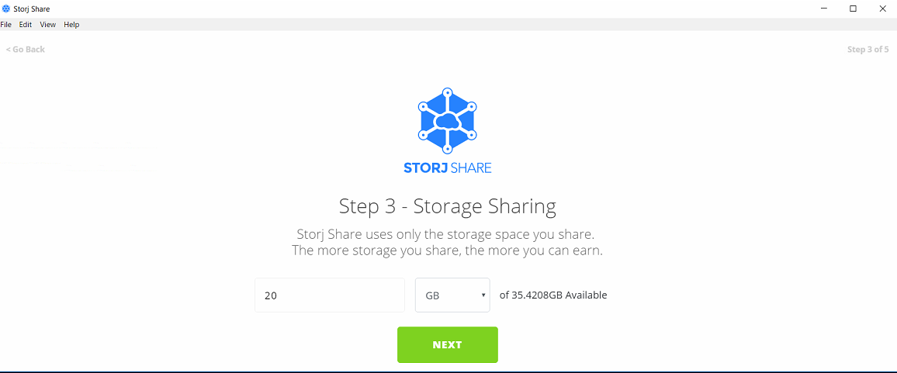

## When ready, click [Next]

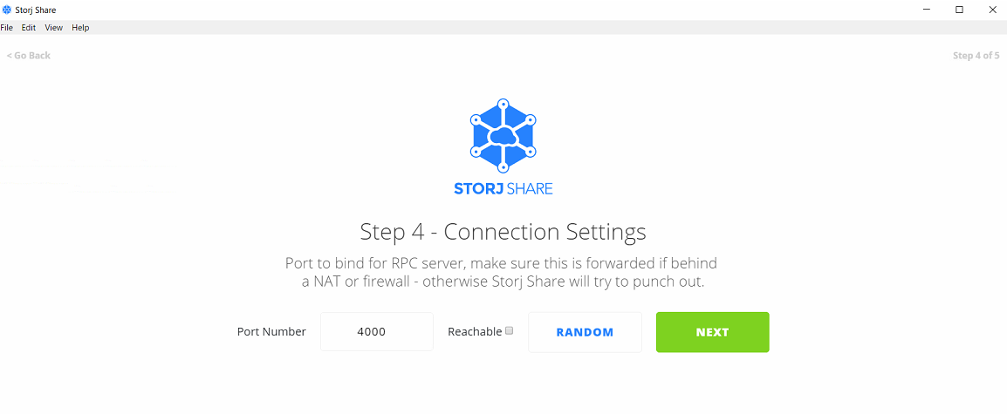

## Storj will do a few checks and prepare everything, then it will connect to the network. As Storj Share is running, you will notice that the designated folder will get filled up over time and your contract number will increase. In due time you'll start receiving Storj on the wallet you created.

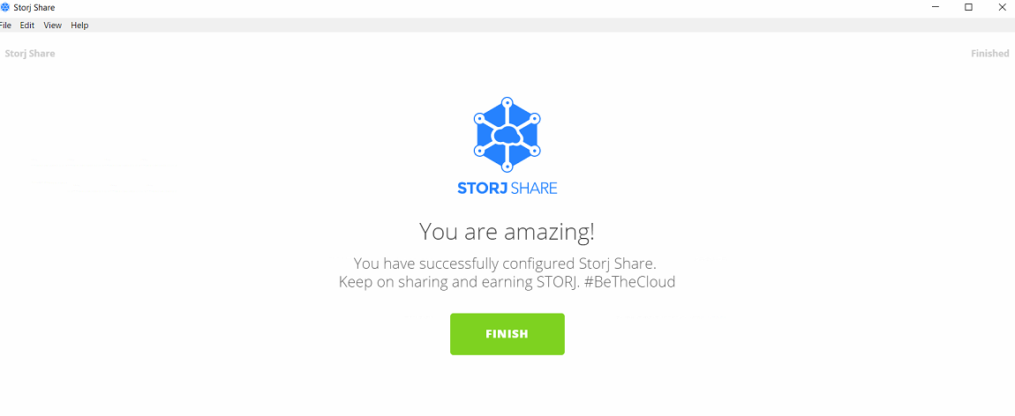

## If you want to add more space to Storj Share you can click on the [Add Drive] field, then select [Add new drive]

## You run the process by pressing [Start] button in the upper right corner.

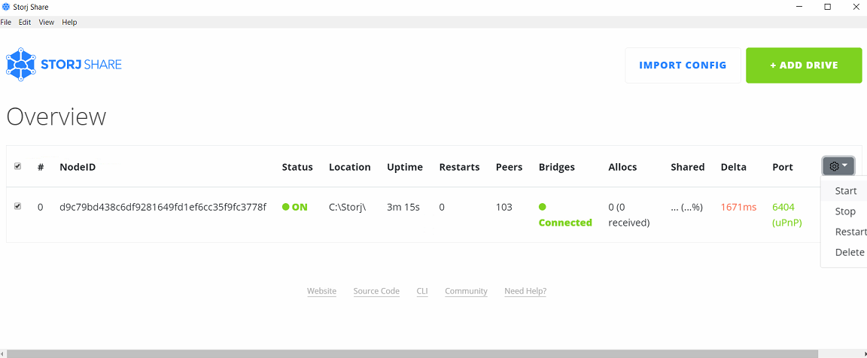

**That's it! You are now a Storj miner!**